The Impact of Public Services on the Severity of Natural Disasters

In the aftermath of disasters, the focus turns to casualties and the impact of the disasters on infrastructure and the economy. These discussions highlight the severity of the hazard. While important to bring attention to, a key component that gets lost is the variation of the severity of the disaster across communities and why there is a variation. While disasters do not differentiate between race, gender, and ethnicity, experiences of hazards vary.  As such, when thinking of disasters, it is imperative to think of them holistically and unpack not only the determinants of the hazard but also the factors contributing to the variation in experiences. This paper argues that natural disasters should be viewed through the lens of disparities in social systems. Disparities in human social systems mold the resources and protections afforded to individuals and communities, which in turn will impact how vulnerable they are to the effects of disasters. Studies in the US have shown that neighborhoods with majority-minority communities are more likely to live close to a waste facility (Pulido, 2000; Pulido et al., 1996). At the same time, on a global scale, developing countries are more likely to have more casualties from disasters even if the number of disasters is the same (Kahn, 2005). The effects of natural disasters can also vary across other factors, such as sexual orientation and disabilities. Ssennoga et al. (2022) found that in Uganda, people with disabilities are more likely than non-disabled individuals to live in areas at significant risk of landslides because of the ostracization and stigma they face from society. These studies highlight that factors such as social networks, income, race, gender, ethnicity, and institutional support all influence the construction of vulnerability and adaptive capacity. The United Nations Office for Disaster Risk Reduction defines adaptive capacity as "the ability of a system to adjust or change its characteristics to moderate potential damage, take advantage of opportunities, cope with the consequences of shocks or stress, and implement adaptation options" (UNDRR, 2022, p.4).  As such, this paperfocuses on the adaptive capacity of communities, with particular emphasis on institutional support.

This paper is an empirical study of the influence of state spending on higher education, highways, public welfare, housing, and community development on the number of disaster emergencies declared by state governments in the United States. The focus is on the number of state disaster emergency declarations because these emergencies are not solely due to the severity of disasters. Less severe hazards can still be devastating if the community lacks coordinated and adequate response resources. Hence, the main question guiding this study is, "How does a state's investment in public services influence the ability of states to respond to natural disasters?".

Data on state expenditure was collected from the US Census Bureau and the Federal Highway Administration, while the number of disaster declarations were collected from the Federal Emergency Management Agency (FEMA). A negative binomial model was then used to assess the relationship between these variables. Education expenditure has the greatest impact on the number of disasters, while highway and public welfare expenditures were also significant. Highlighting that greater investment in these areas decreases the likelihood of a natural disaster declaration.

The paper is divided into three sections. The first covers vulnerability, adaptive capacity, and state influence. The second section covers the data collection, variables, and negative binomial model results. The last section includes the discussion and conclusion.

Institutions and Adaptive Capacity

Disaster studies often hone in on the natural factors that lead to hazards and the impact of the disasters on industries, causalities, and how they shape future mitigation practices. However, increasing literature has moved away from this sterile analysis and taken a more nuanced approach that looks at the impact of disasters as the result of social dynamics. Cannon (1994) argues that social construction explains the variation in disaster impact. That is directly due to how "opportunities and risks are fashioned by the varying characteristics of different types of social systems, and the different demands each society puts on nature, combined with the varying impacts that nature may have on the types of social system" (p.14). Furthermore, believes that while hazards come about naturally, what transforms a hazard into a disaster is its ability to affect vulnerable people. If we then accept that the impacts of disasters are a social construct, we turn our analysis to societal makeup and its determinants. One of the most important determinants is institutional influence. Studies have approached institutional support through various lenses. Kahn(2005), in an analysis of the number of people killed during a disaster, found that institutions are critical. The focus on institutions was quality; hence, it looked at factors such as the democracy level, good governance indicators, and income inequality. Governments that scored higher in these categories were more likely to experience fewer deaths. These findings were mirrored in Tol's (2012) study on state capacity and vulnerability. State capacity was operationalized through their ability to provide public goods. Tol found that raising taxes was an effective method to reduce disaster vulnerability. Another important indicator of how well a community is prepared for a disaster is education. Skidmore (2019) found that education was a good predictor of how much a disaster will impact a community. In a study of individuals most impacted by flooding, poor education, and housing quality were important determinants of the severity of the flooding. Furthermore, local government investment in these communities was a salient factor.

These studies prove that states are influential in building the capacity of communities to respond to disasters. Hence, my study builds on these findings to better understand the relationship between the level of investment in public services and the number of disaster declarations in the United States.

Disaster Declarations

The United States has a federalist system, with the federal government setting broad policies regarding disaster response, but each state has its own policies and procedures regarding disaster response.  Disaster declarations can be made at the local, state, and federal levels, and consider the mortality rate, damage to infrastructure, and strain on resources (FEMA, 2024). The federal government only becomes involved after the state governor declares an emergency and, from there, sends a request to the federal government. FEMA, in turn, only gets involved after conducting its own assessment, which shows that state resources cannot keep up with the impact of the disaster (FEMA, 2024).  For example, in the case of the Flint Water Crisis, lead had seeped into the water after switching the water source for the city in 2014. Mere months after the switch happened, residents complained about foul odors and smell, with many getting sick. In terms of declaring an emergency, however, it took a year until a local state of emergency was declared and two years until a declared emergency on the state level (Ruckart et al., 2019, p.4).

            As state disaster declarations consider factors outside of the severity of the disasters, the dependent variable for this study is the number of declarations made by states.

Data Collection

I created a dataset containing yearly expenditures for each state on highways, higher education, public welfare, and housing and community development. The data has yearly information from 2012-2022. The data was collected from the US Census Bureau and The Federal Highway Administration. The number of disaster declarations was collected for each year and collected from the FEMA declarations website. I did not include disasters that were considered biological (e.g., Covid) and only collected natural disaster numbers. I also did not include any data from the District of Colombia.

Variables:

In the data set, I coded the independent variables as:

* Hwy_Exp: Highway Expenditure
* Hcm_exp: Housing and Community Expenditure
* Pw_exp: Public Welfare Expenditure
* Ed_exp: Higher Education Expenditure

In turn, my hypotheses are:

*H1- Investment in robust, public welfare programs will reduce the likelihood of a disaster declaration*

*H2- Investment in higher education will reduce the likelihood of a disaster declaration*

This hypothesis is party informed by Muttarak and Lutz (2014). They argue that one of the best mechanisms for creating lasting and impactful disaster mitigation practices is through an investment in education. Communities that are more educated tend to know more about climate change, have a keener understanding of disaster threats, and will, in turn, be more open to training and know what to do during disasters.

*H3- Investment in highways will reduce the likelihood of a disaster declaration*

Patterns and Models

To better understand the patterns between these variables and check for the number of 0s in the dataset, I created a histogram of the frequency in the number of declarations and the number of declarations by year. Figure 1 shows us that a large quantity of the dataset included 0's. I had initially planned to use a Poisson model for the data, and the histogram highlighted the need to consider a zero-inflated/negative binomial model. Furthermore, Figures 2 and 3 show that the number of disaster declarations has stayed relatively constant throughout the years despite increased expenditures on services such as highways.

I first fit a Poisson model and tested it for overdispersion. The results showed state expenditures on highways, public welfare, and education were all significant, with education being the most significant. However, when assessing if this model is the correct one for my data, an assumption with Poisson is that the mean is equal to the variance. Hence, if there is overdispersion, another model will be best suited. The ratio is much more than 1; hence, we can conclude that another model will best suit.

Table 1

Poisson Results

========================================================================

Number of Disaster Declarations

------------------------------------------------------------------------

Intercept -0.000***

(0.000)

Highway -0.000***

(0.000)

Housing and Community Development 0.000

(0.000)

Public Welfare 0.000***

(0.000)

Higher Education 0.552***

(0.048)

Observations 550

Log Likelihood -1,156.676

Akaike Inf. Crit. 2,323.353

------------------------------------------------------------------------

Notes: ***Significant at the 1 percent level.

**Significant at the 5 percent level.

*Significant at the 10 percent level.

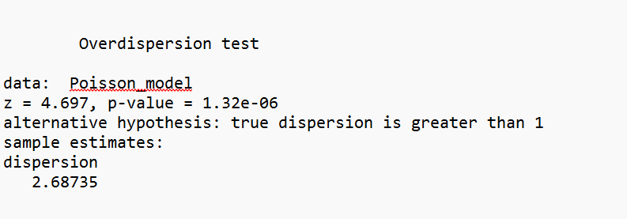

I then ran a negative binomial model. The negative binomial model is suited for overdispersion.

Table 2

Negative Binomial Results

========================================================================

Number of Disaster Declarations

------------------------------------------------------------------------

Intercept -0.000

(0.000)

Highway -0.000***

(0.000)

Housing and Community Development 0.000

(0.000)

Public Welfare 0.000***

(0.000)

Higher Education 0.497***

(0.072)

Observations 550

Log Likelihood -1,020.945

theta 1.483*** (0.177)

Akaike Inf. Crit. 2,051.890

------------------------------------------------------------------------

Notes: ***Significant at the 1 percent level.

**Significant at the 5 percent level.

*Significant at the 10 percent level.

Education, highway, and public welfare spending were all significant. From the highway coefficient, we can see that increased highway spending will decrease the likelihood of a disaster declaration by e^ 6.113e-08.  Hence, it fails to reject H3.  The coefficient for education, however, shows us that an increase in education expenditure increases the likelihood of disaster declarations by e^ 6.713e-08. As such, reject H2. The coefficient for public welfare was also e^ 2.545e-10 and rejected H1.

As the results for some of the variables were surprising, I plotted the residuals to analyze model fit.  Table 3 and 4 highlight that the model fits the data well.

Table 3

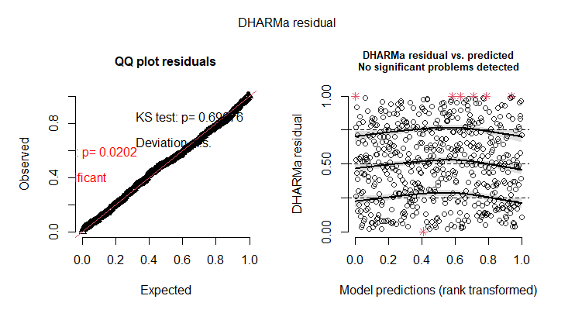

Table 4

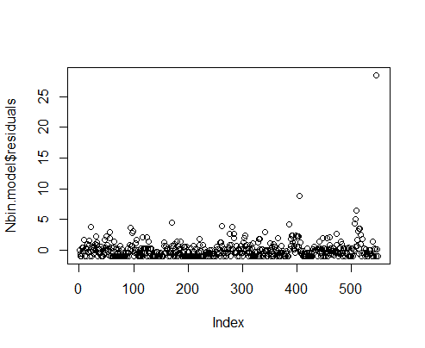

Conclusion

The findings highlight how important infrastructure investment is, as roads and buildings are the first things to crumble during disasters. If these are impacted, it has spillover effects, making it more challenging to provide rescue operations, emergency health services, and clear debris. However, while significant, the impact is minimal. Furthermore, the covariates for education and public welfare highlight this study's limitations and opportunities for further exploration. There is a possibility that these covariates can be explained by states with higher education and public welfare investment, which may also have more disasters on average. While several of the variables were significant, their impact was also small. An opportunity to further unpack these variables through a fixed effect panel analysis. However, while the relationships are not overtly strong, this study provides evidence that state expenditure on public services impacts the number of disaster declarations.

References

Cannon, T. (1994). Vulnerability analysis and the explanation of ‘natural’disasters. *Disasters, development and environment*, *1*, 13-30.

FEMA. (2024). *How FEMA works*. FEMA.gov. <https://www.fema.gov/about/how-fema-works>

Kahn, M. E. (2005). The Death Toll from Natural Disasters: The Role of Income, Geography, and Institutions. *The Review of Economics and Statistics*, *87*(2), 271–284. <https://doi.org/10.1162/0034653053970339>

Lim, J., & Skidmore, M. (2019). Flood Fatalities in the United States: The Roles of Socioeconomic Factors and the National Flood Insurance Program. *Southern Economic Journal*, *85*(4), 1032–1057. https://doi.org/10.1002/soej.12330

Pulido, L. (2000). Rethinking Environmental Racism: White Privilege and Urban Development in Southern California. *Annals of the Association of American Geographers*, *90*(1), 12–40. https://doi.org/10.1111/0004-5608.00182

Pulido, L., Sidawi, S., & Vos, R. O. (1996). An archaeology of environmental racism in Los Angeles. *Urban Geography*, *17*(5), 419-439.

Ruckart, P. Z., Ettinger, A. S., Hanna-Attisha, M., Jones, N., Davis, S. I., & Breysse, P. N. (2019). The Flint Water Crisis: A Coordinated Public Health Emergency Response and Recovery Initiative. *Journal of Public Health Management and Practice*, *25 Suppl 1, Lead Poisoning Prevention*(1), S84–S90. https://doi.org/10.1097/PHH.0000000000000871

Ssennoga, M., Mugagga, F., Nadhomi, D. L., & Kisira, Y. (2022). Mapping the susceptibility of persons with disabilities to landslides in a highland landscape of Bushika Sub County, Mount Elgon, Eastern Uganda. *Jamba*, *14*(1), 1266–1266. https://doi.org/10.4102/jamba.v14i1.1266

Tol, R. S. J. (2021). *State capacity and vulnerability to natural disasters*. https://doi.org/10.48550/arxiv.2104.13425

UNDRR. (2022, April 26). *Gar2022: Our World At Risk (GAR)*. <https://www.undrr.org/gar/gar2022-our-world-risk-gar#container-downloads>